Home page

1 ## Needs to be discuss with Shilpi

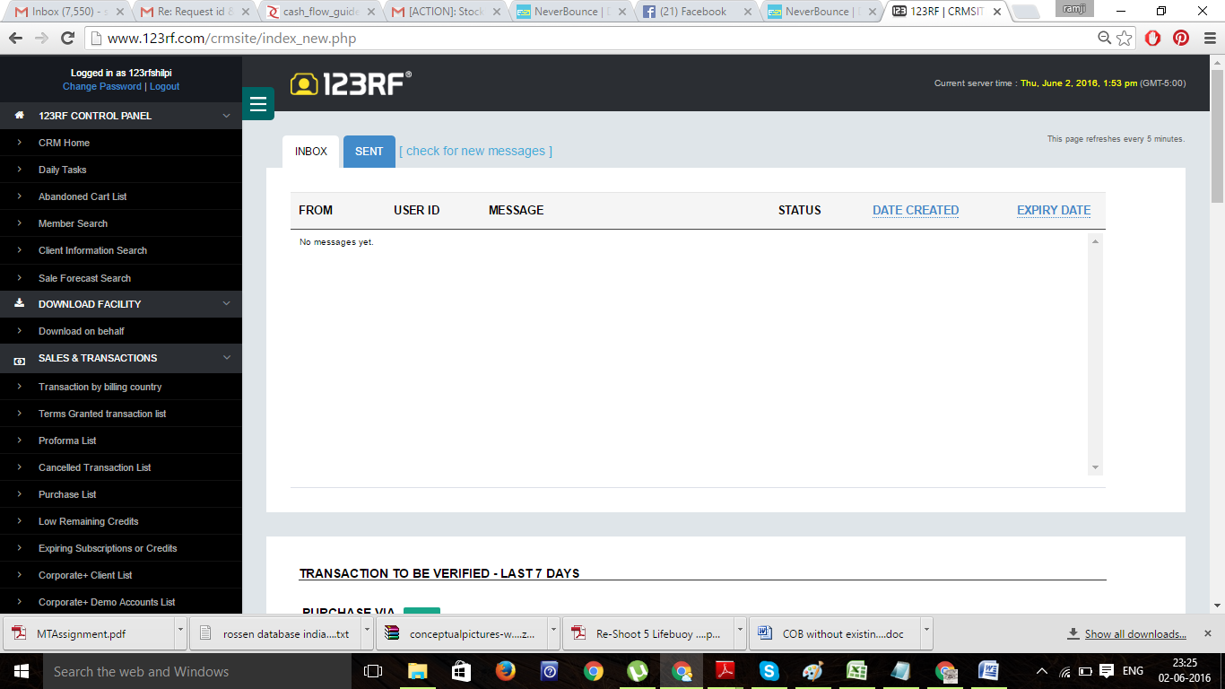

**Table Name:** orders>>> Columns: txn_id, user_id , subtotal (Amount), order_status (Status), created (Time)

**Table Name:** users>>> Columns: email, First name, Last name, Country, Payment Method

What is “CREDITS” here

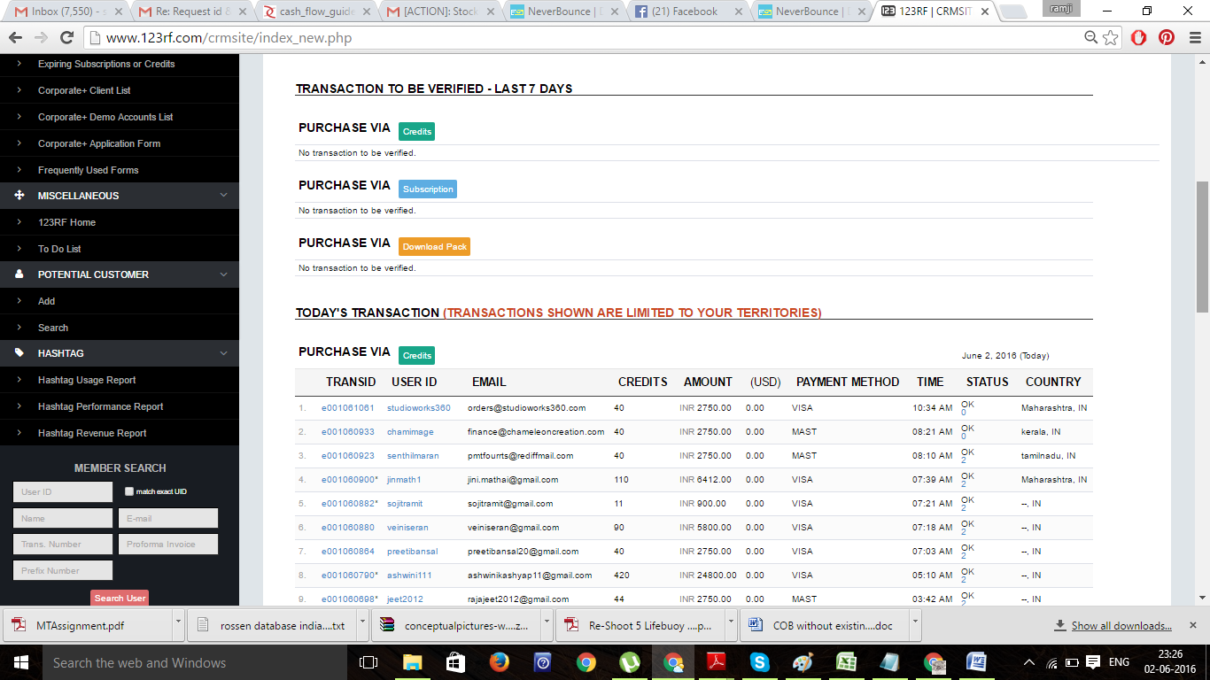

Daily Task

2 ## Needs to be discuss with Shilpi about license expiry for image subscription

**What is renewal & Expire here?**

**Renewal make sense where we sell any product like insurance but here what renewal means?**

Table: Users; column – country, state,

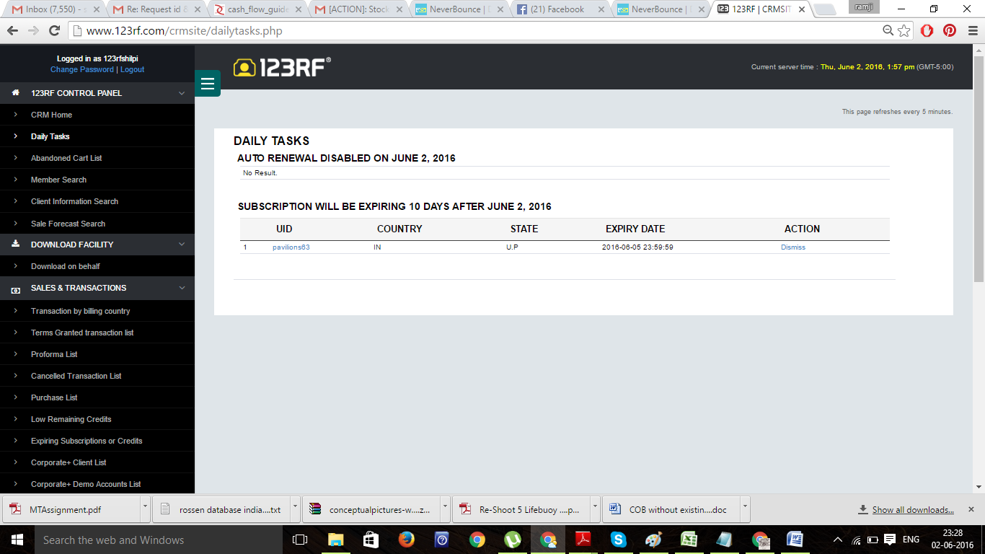

**3 [Payment module is not integrated so we will take care of this in coming days]**

1 ## Needs to be done later afer payment module

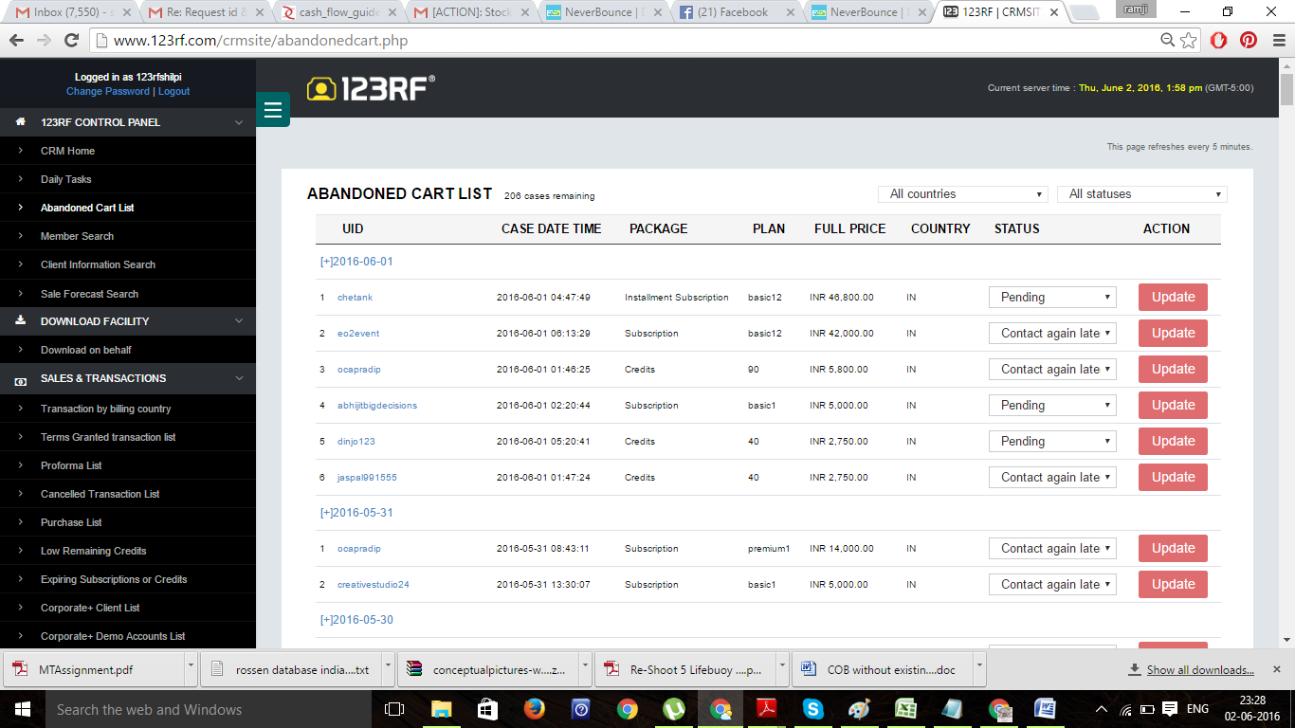

Member search

4 **Table: users -**

**Columns: firstname, lastname, email, city, zipcode, state, company, phone, mobile, country, created (Date Register)**

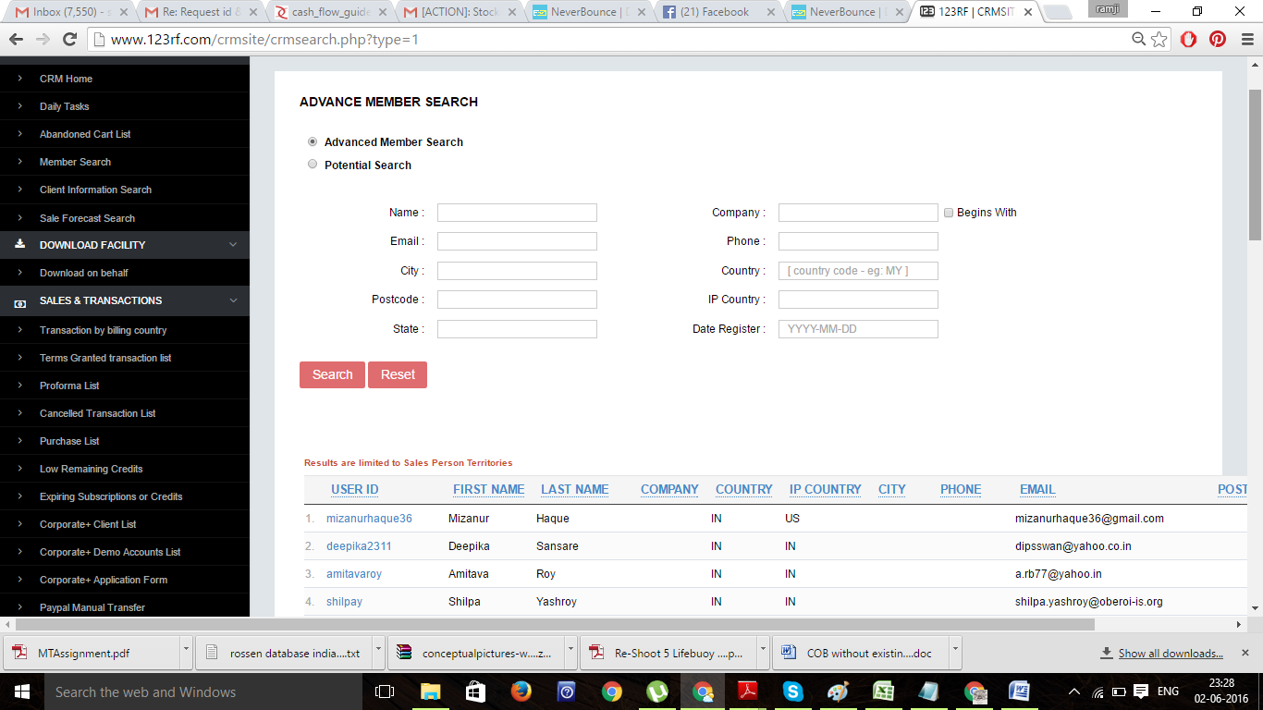

Search client information-4

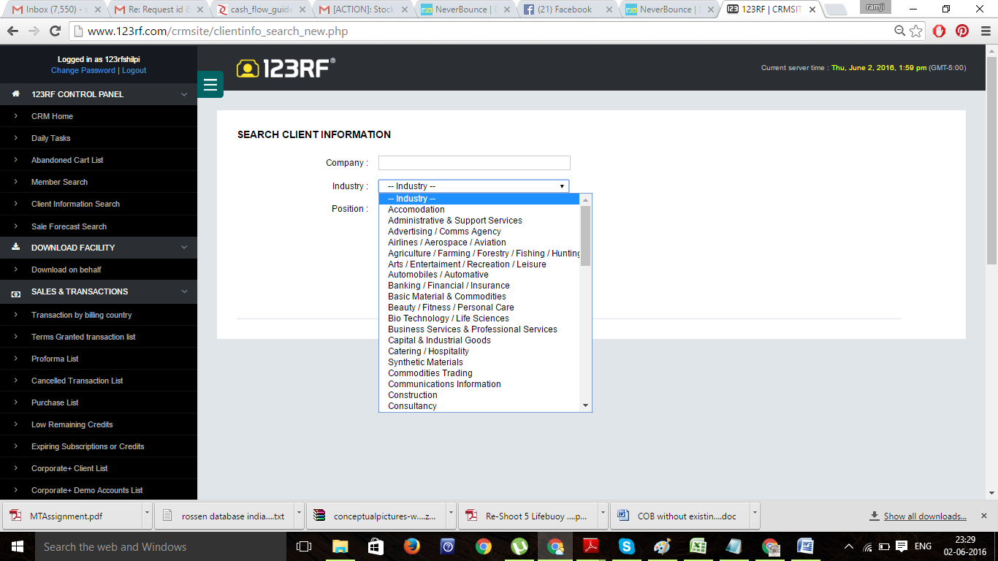

Sales forecat search

5 1 ## Needs to be discuss with Shilpi

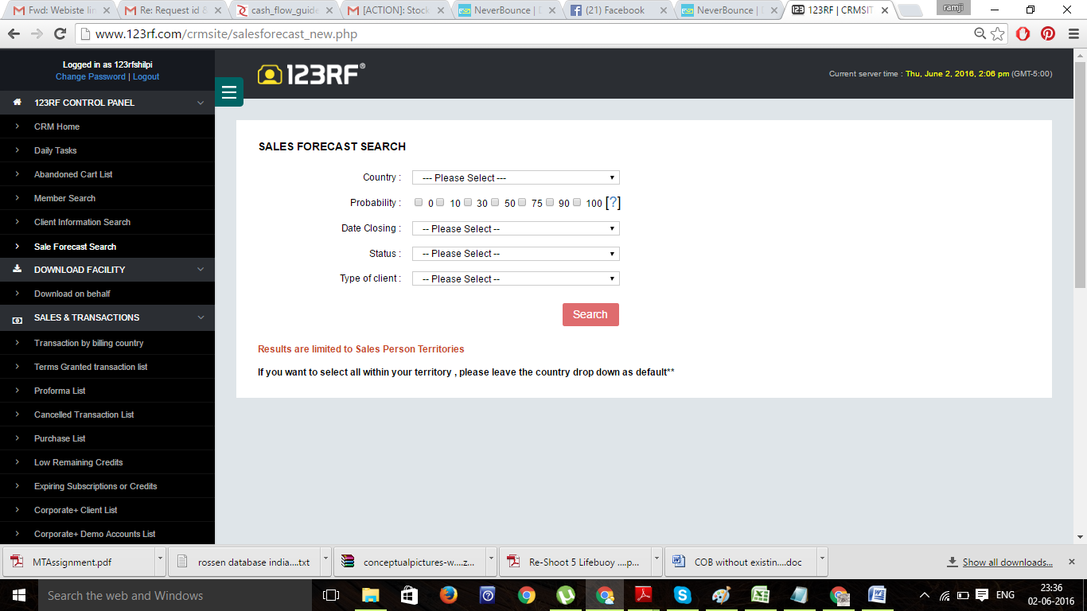

Download on behalf- 6

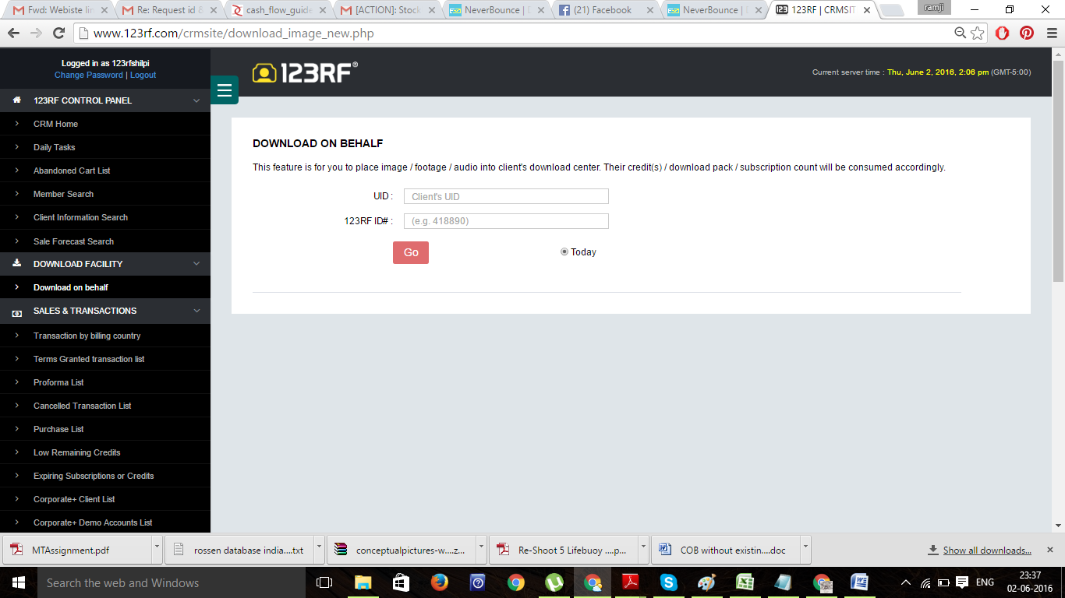

Transaction search : usually 100 items appear on 1 page

Table: orders #Columns: created (Date from/date to)

Table: users #Columns: country

Payment method/Type/Status will be take care in payment module

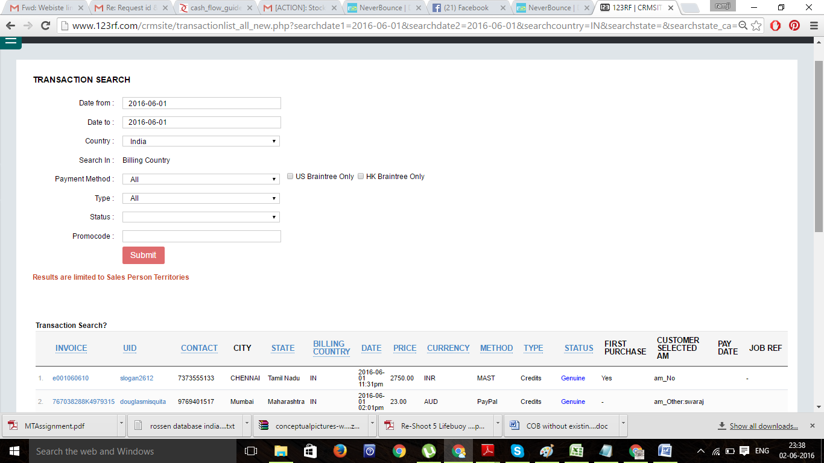

Proforma list- 8

Invoice generates after payment so depend on payment module

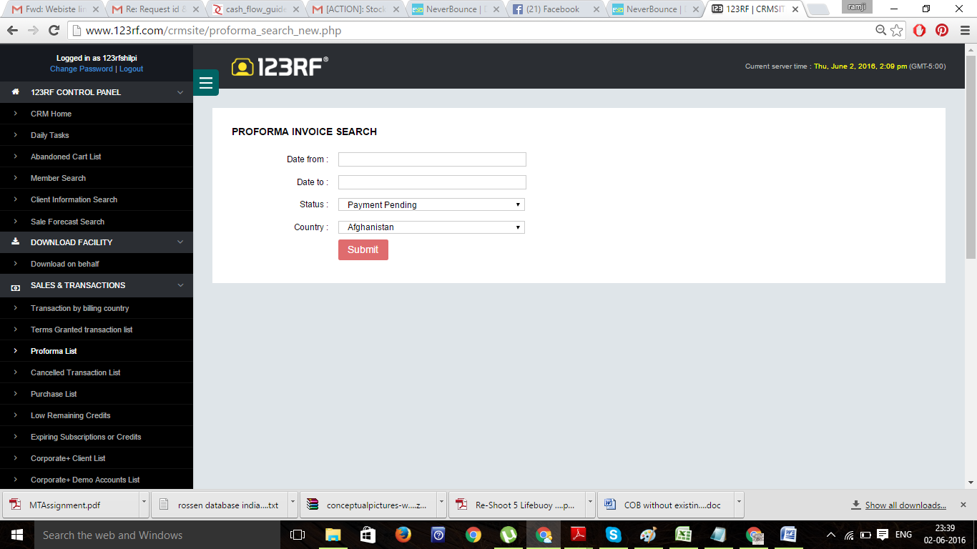

cancelled transaction- 9

Dependency on payment module.

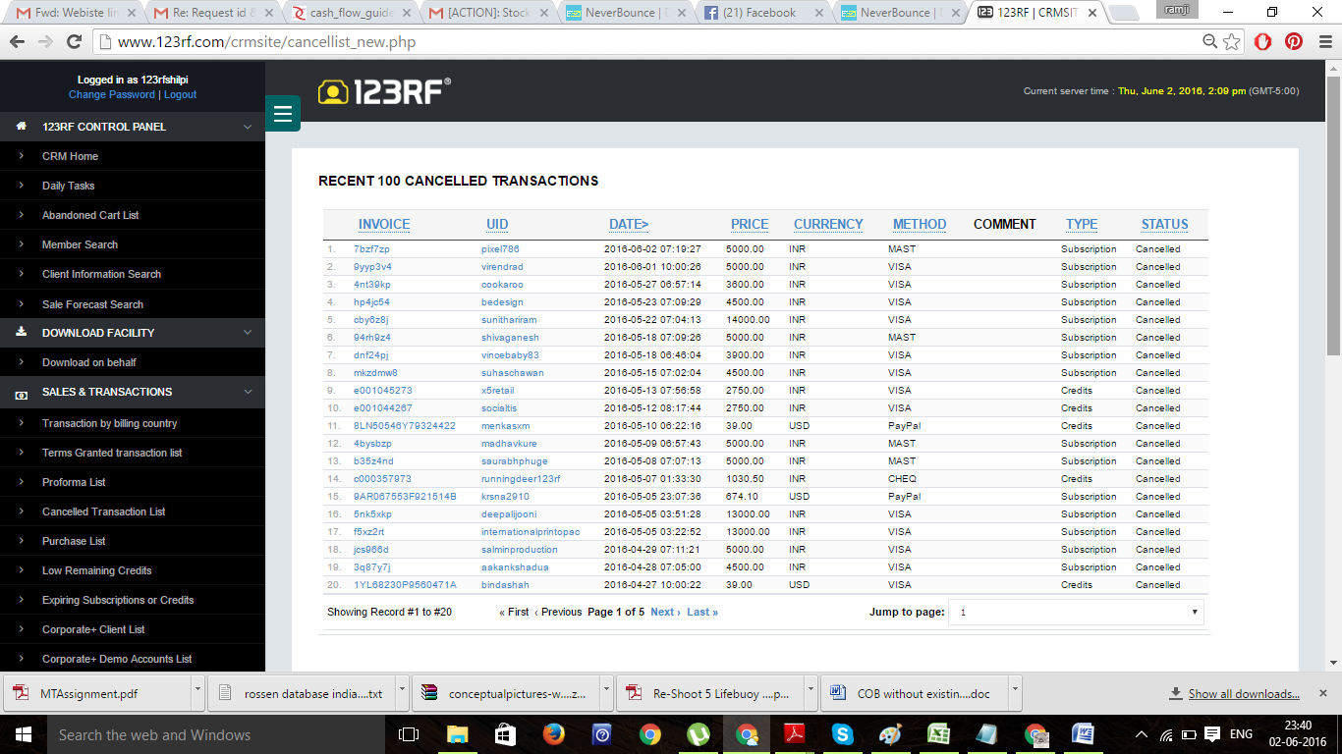

Low remaining credit list- 10

What it means: **Low remaining credit List**

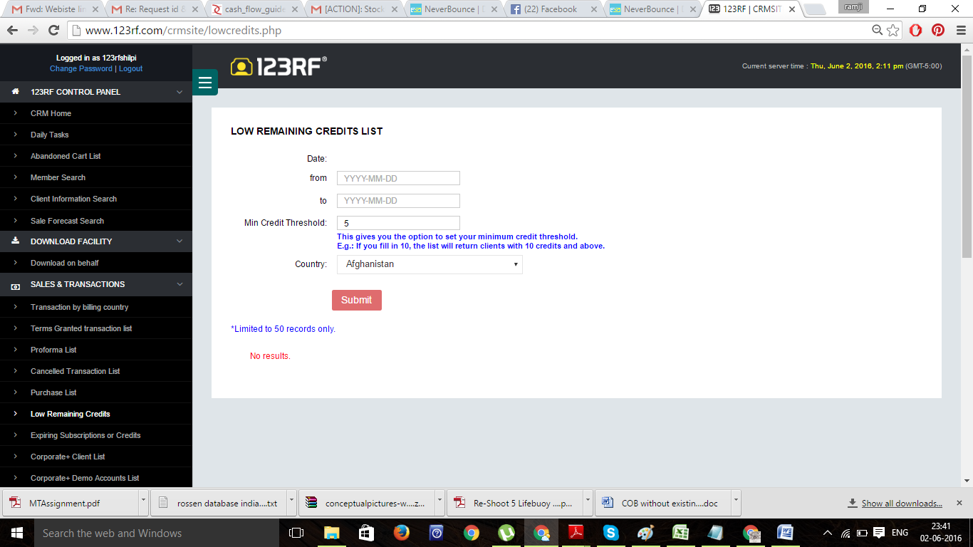

expiring subscription- 11



Paypal manual transfer- 12 (dependency on payment module)

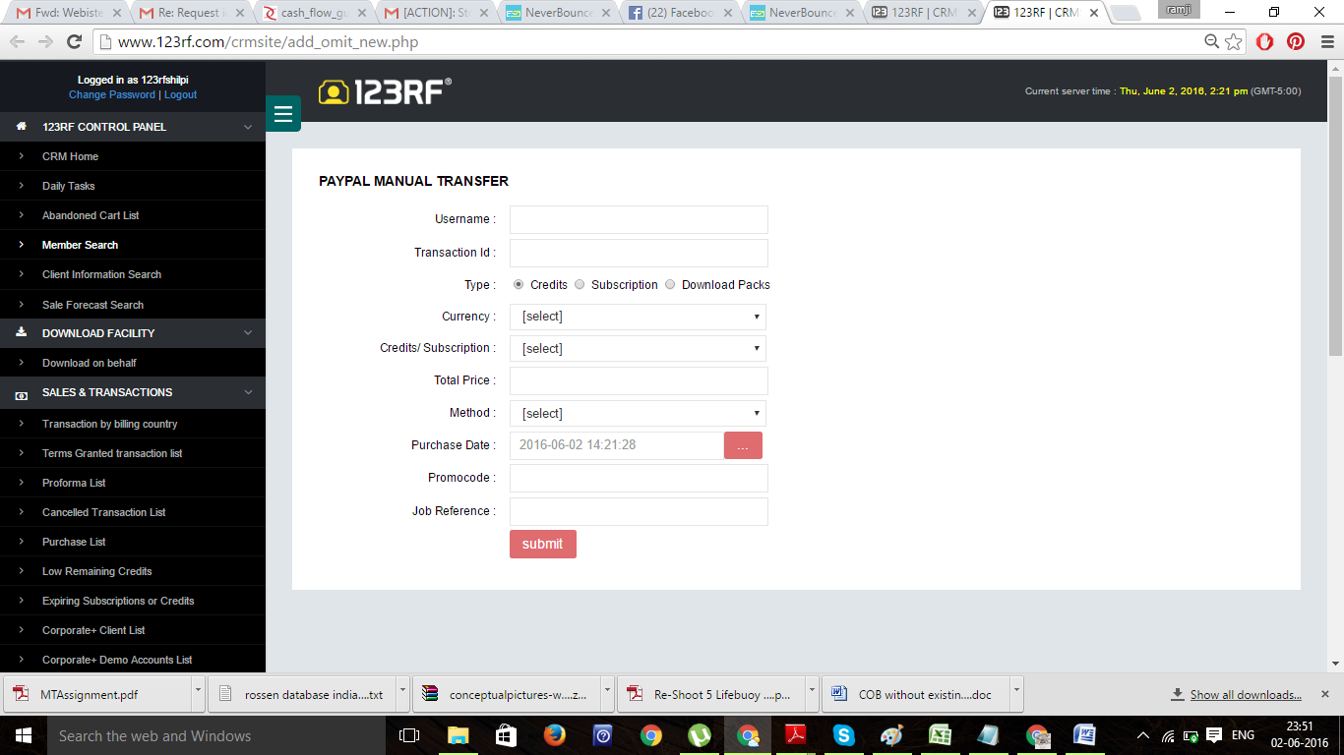

Member search- 13

Table **users**

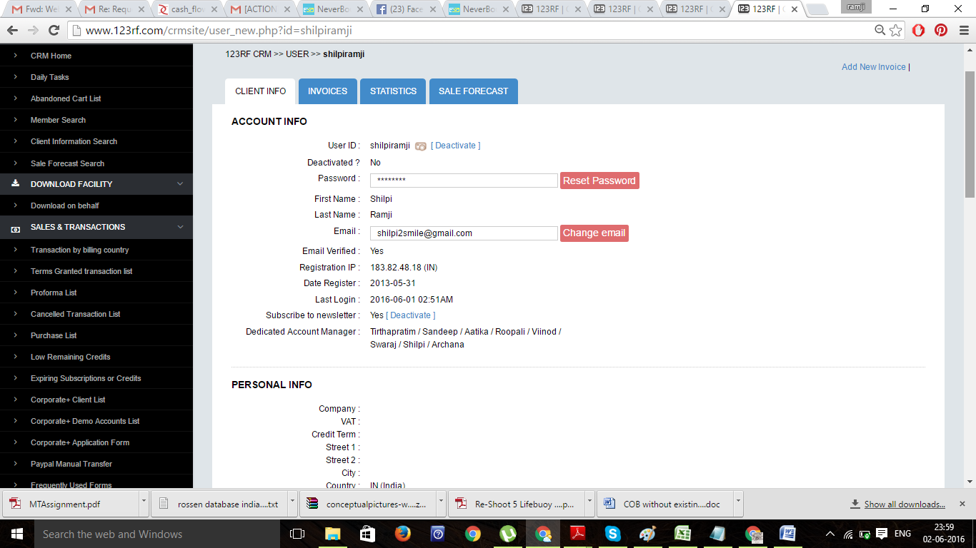

14

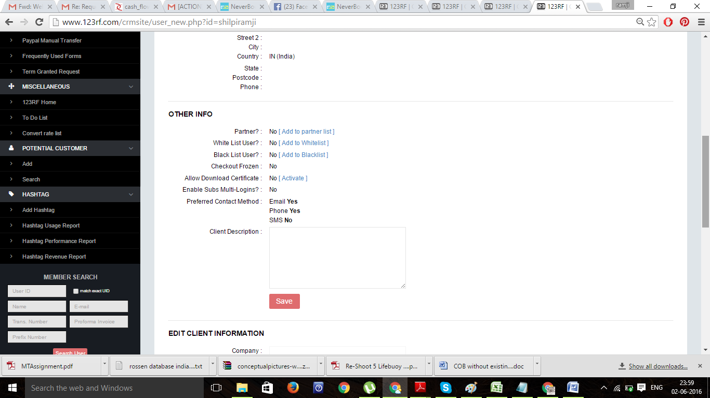

15

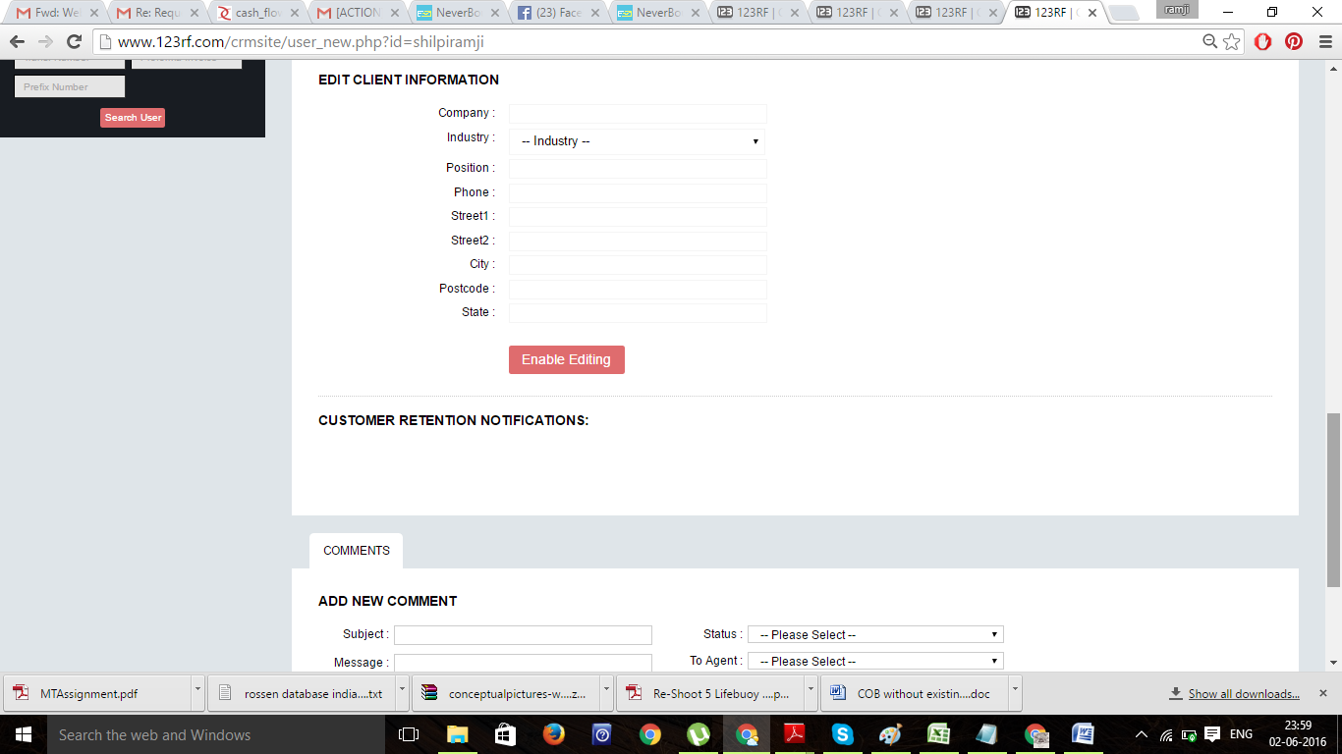

16

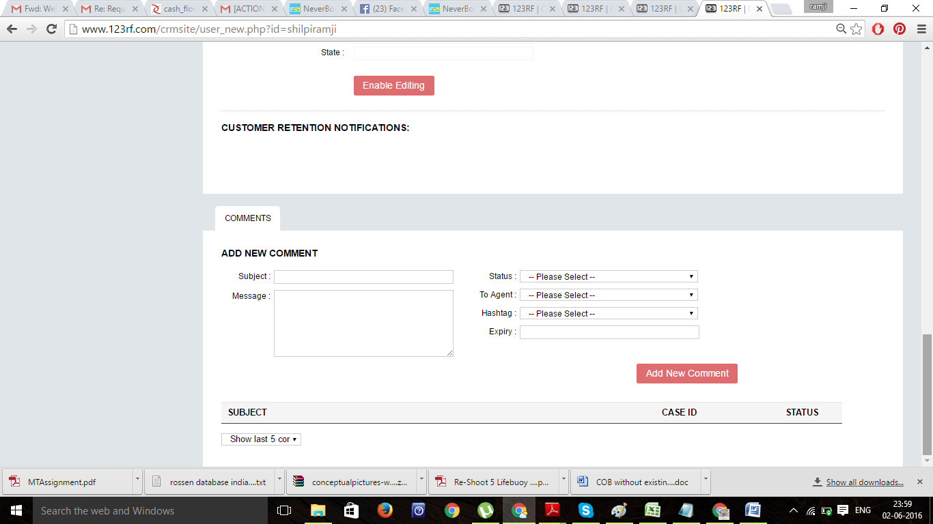

17

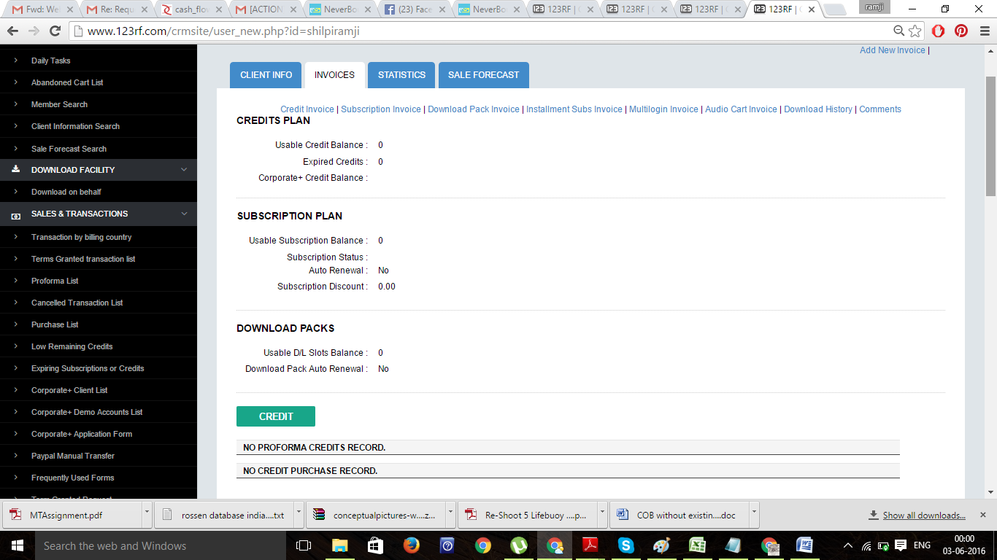

18

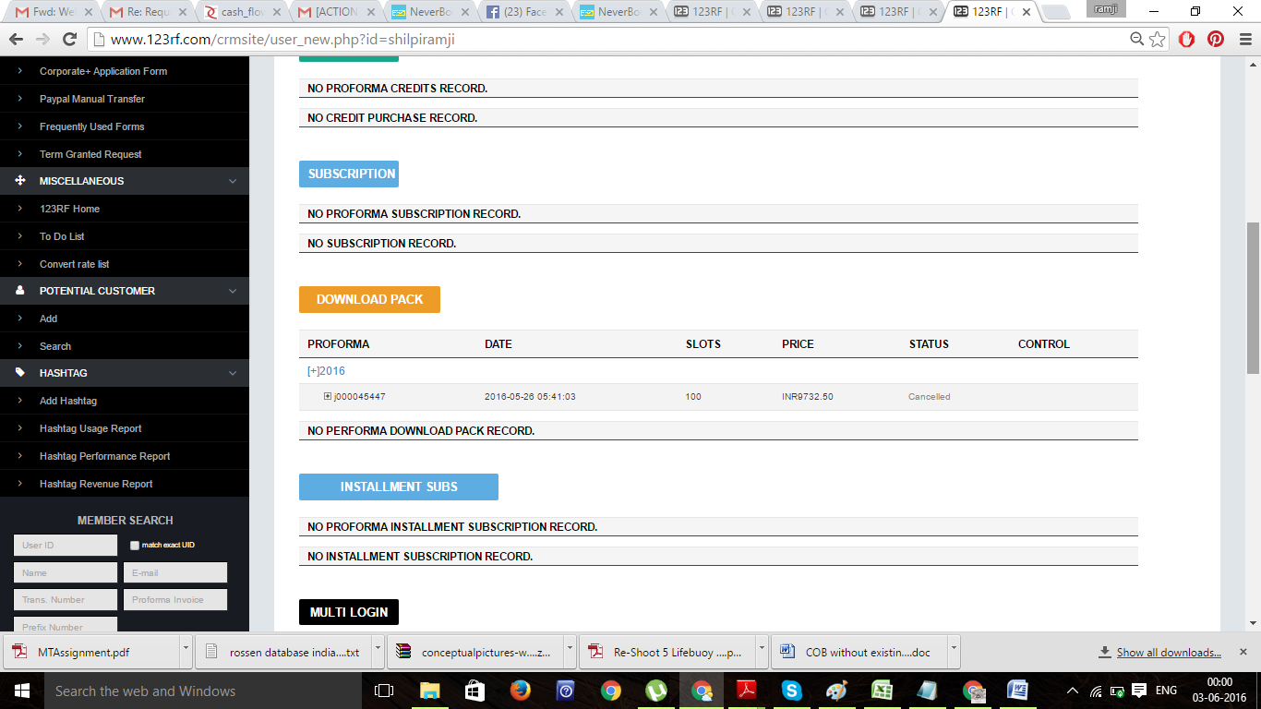

19

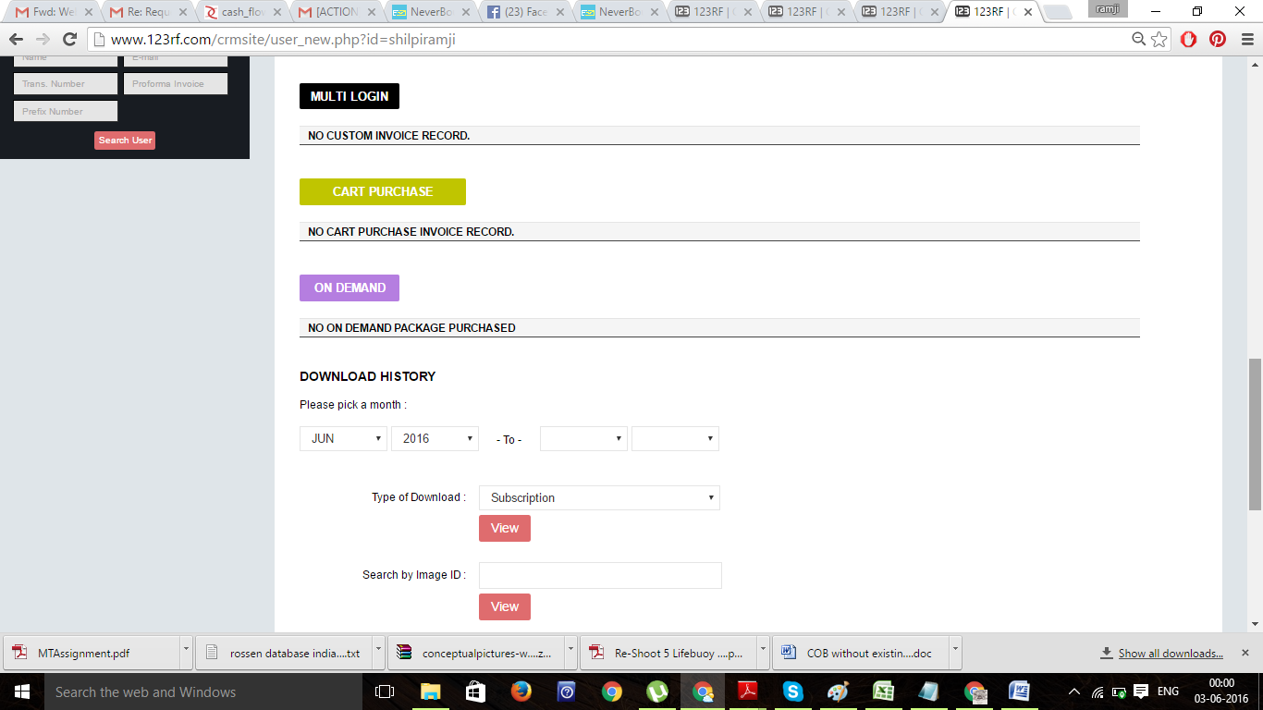

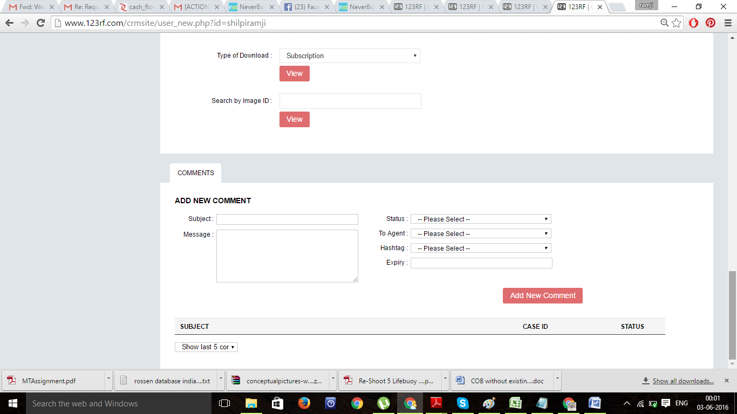

20

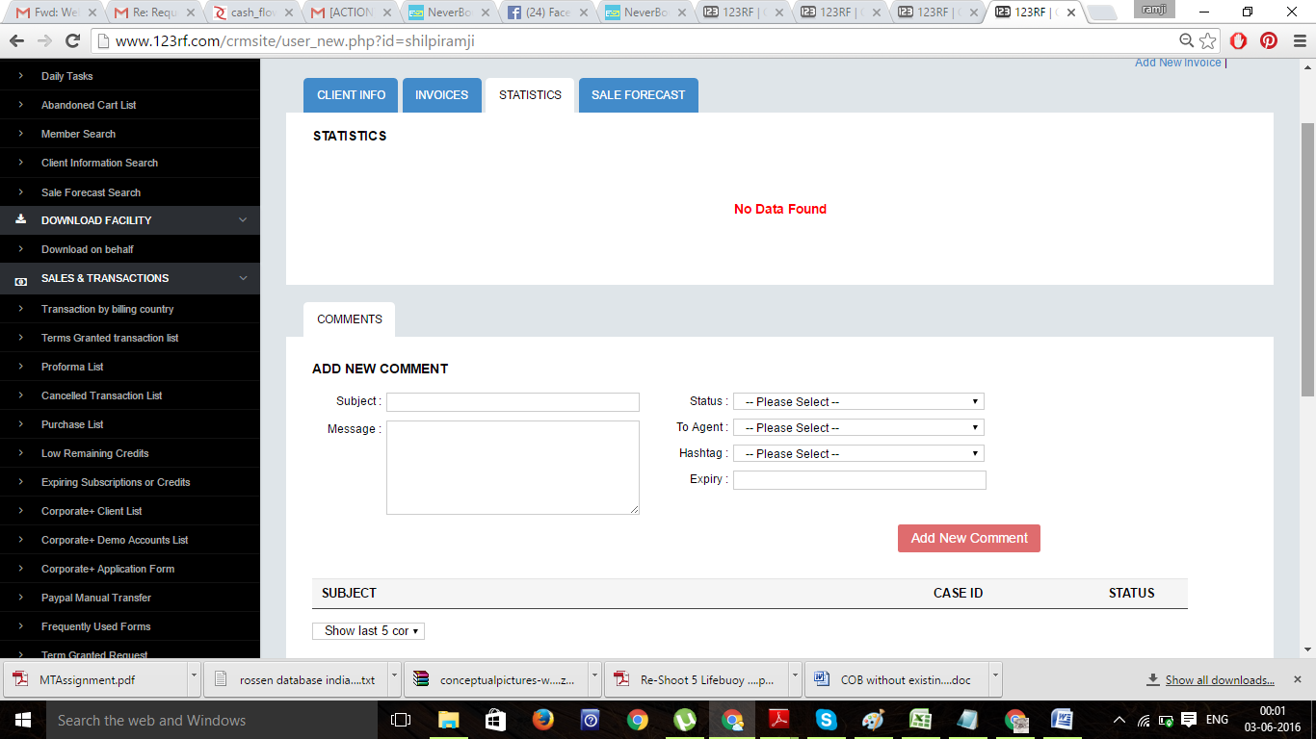

21

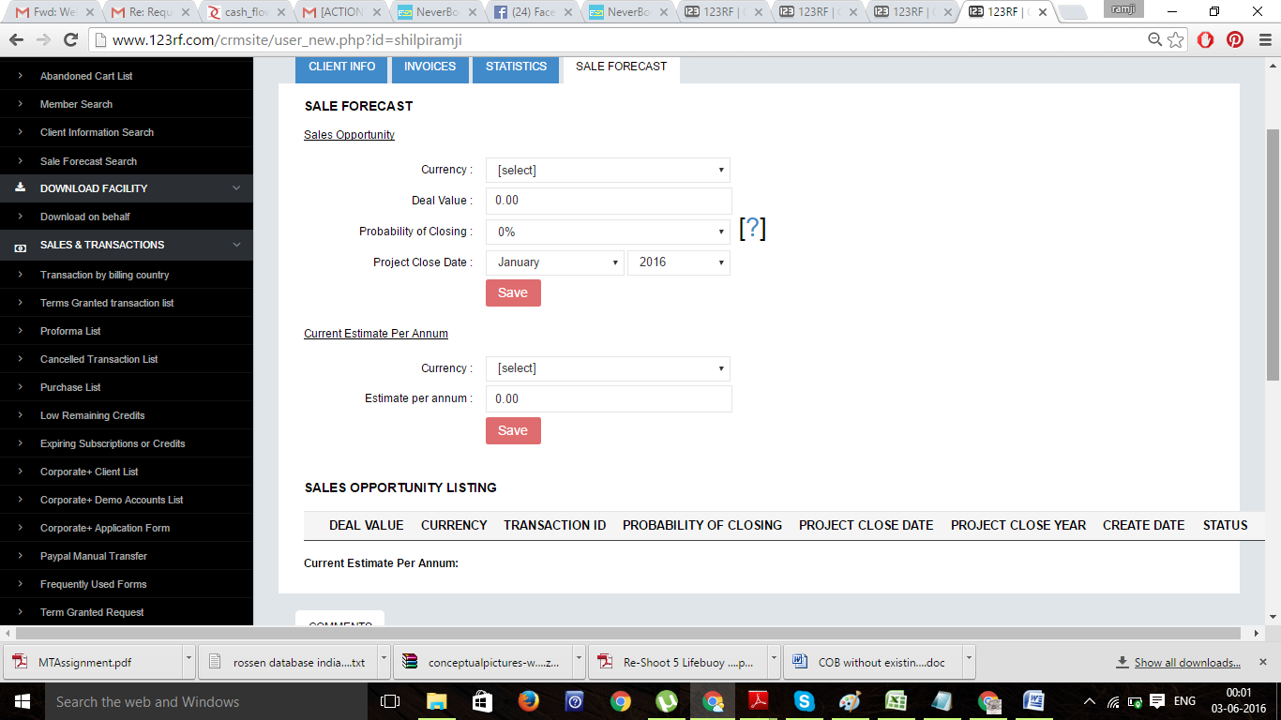

We should also have option to create Client account in the CRM.

These CRM will be operated by various Client servicing team and accounts team with their Individual User IDs and passwords.

Once client goes into a client’s account, they are able to create Invoice, initially Proforma Invoice( PI)/ Quotation and then once it is approved, the status of the PI has to be manually changed to complete, when another Tax Invoice gets generated with another unique serial number and both of these invoice/Quotations are available online.

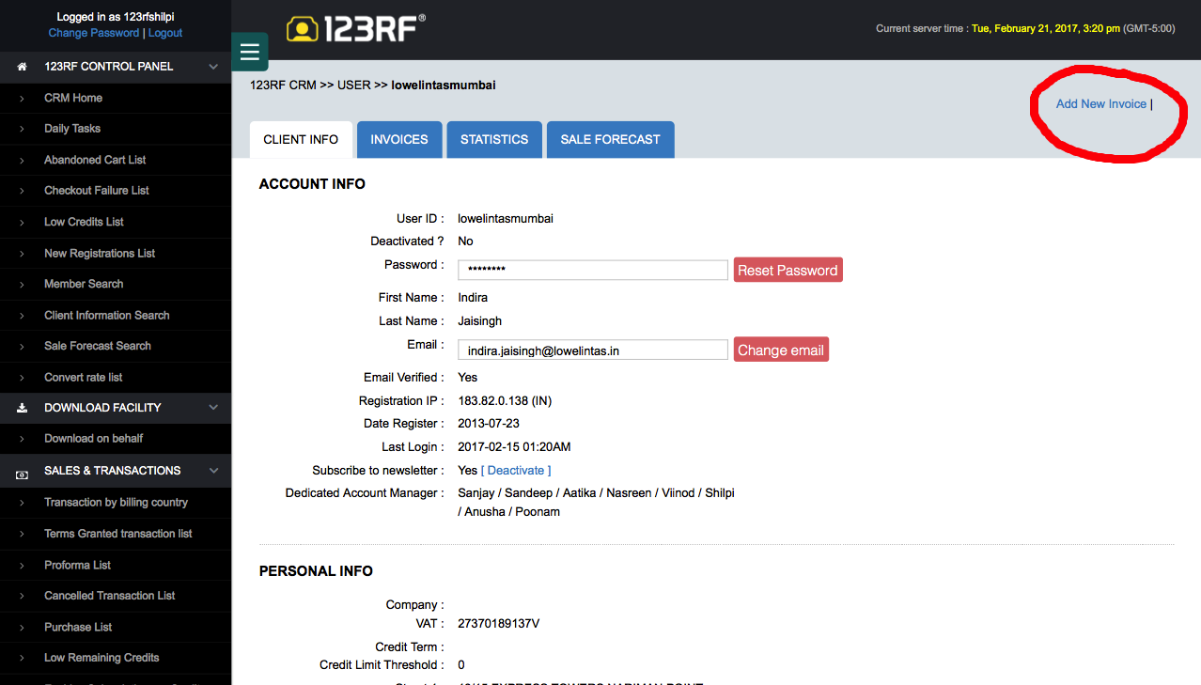

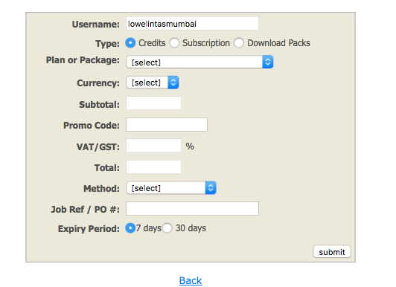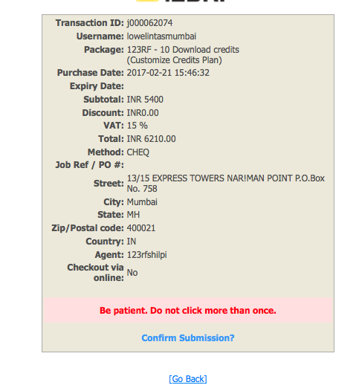

Now what we need here is little customisation. On top under **TYPE** we need another field **Images,** If you select images, then Under Images, No of Images, Image Nos(unique no of individual image), Image upload option, size should be the smallest ,Against image nos; RM/RF in dropdown and sizes in dropdown and cost of each image

Then Sub Total, Promo code etc as above.

Under RM images we need a lot of License Details that needs to be captured on the Invoice, hence please follow the below link to create those fields.

http://www.masterfile.com/search/enlarged_pricing.html?img=700-06961979

Performa Invoice/ Quote Sample as below

Invoice Sample



Proforma Invoice/ Quotation sample with Images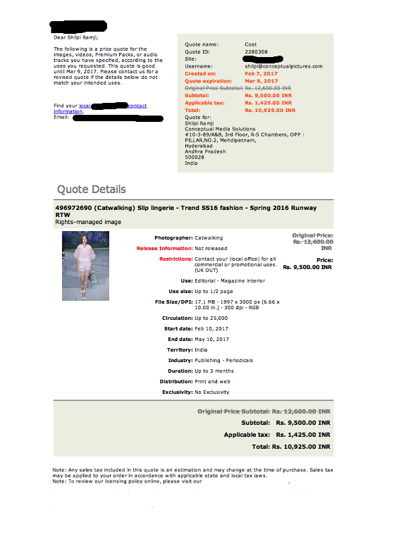

Sample Tax Invoice with Images

